Technological disruption
- Conglomerates exist to take advantage of cost and revenue synergies. Conglomerates can fill institutional voids in emerging markets by easing the necessity to enforce contracts, giving you access to more accurate information on companies, you can compensate through the lack of VCs through your own large pot of funds.

Disruption
- Speed of disruption has potentially increased.
- Industries are collapsing into ecosystems. Lifespan of companies is going down.
- Competition is more asymmetric now because firms assets and capabilities are diverging. Once you lose the war of value its hard to come back because of increasing returns to adoption and network effects

- Disruptive strategy is a valuable corporate asset that increases the chances of growth from 6% to 37%. If incumbents are disruptive its hard to entrants to succeed.
  - Companies risk becoming too focused on competitors and not customers. More unneeded features also justifies higher prices
  - Performance overshoot represents this. This is what disrupters exploit
- Blue line is the trajectory of the product’s development. Green line shows disruptors who initially have low low low performance but over time becomes closer to what people actually want.

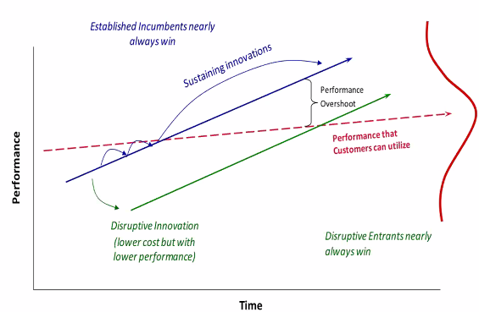
- Minimills entered in the low margin segment of the steel industry, competitors ignored it but then over time mini mills developed further and began to compete directly with larger mills on the high value segments.
- Incumbents often saddled with higher costs i.e. branding costs, often prime real estate rent costs, highly trained staff.
- Business model in which the technology is what is embedded, usually through targeting a specific segment.
- Anything attacking the basis of your comp advantage is disruptive. So you need to know your competitive advantage to assess which disruptors are attacking this.
Why do incumbents struggle when facing disruption?
- Why did Kodak fail? Tried to prolong the life of existing technology as this was the basis of their competitive advantage. Moving away from their speciality is difficult.
  - Not killed by technology or entrants with more resources
  - Their mindset, how they understand their product market,
  - No adventure in tourism – Kodak marketed the function of a holiday as bringing back photographs
- How did Kodak react to digital imagining? Disbelief – people will never compromise on quality and they demand sentimental value. Modifying a photograph destroys its value. Hard prints thought of as a social currency.
  - They know their industry too well, fixed in their mindset as they don’t pay enough attention to ideas that undermine their understanding
- Scaling down is difficult as it is difficult to manage a declining company. Revenues are falling and not covering costs, so decreasing amount of profits to invest into new technologies. Can’t public confess as this would hurry your own demise, retailers and distributors wont stock your product.
  - What to do with people in legacy businesses whose skillset lies entirely in this technology? They try to double-down on the existing cash cow technology
  - Other companies
  - Make money from complementary assets: brand, global networks, capabilities.
    - Shift from women to men, sentimentality to casual, memories to experiences
    - Relationship with the product completely changed
    - Need a multi dimensional view of disruption to transcend it
    - Firms just focus on technology and overlook these other aspects
- Beginning of tech cycle you need unique asset to make your tech the dominate tech. As the dominant design emerges, it becomes about who has the bets complementary assets (big pharma lab capabilities). As disruption hits we start a new curve, and need to recruit new complementary assets (brand, global distribution). Companies find it hard to let go of them because of the money they’re generating

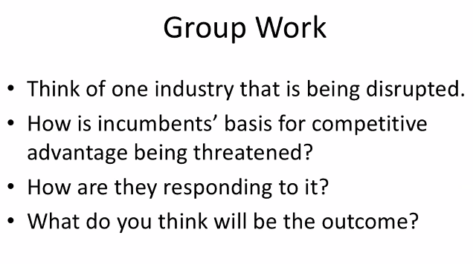

Further Reading

The Innovator’s Dilemma (Christensen, 1997)
Successful companies can do everything right and still lose their market leadership due to the innovation S-curve and the burdens of the incumbent.

Reasons for failure
- Value of innovation follows an S-curve: improving a product takes time and many iterations.
  - First iterations provide minimal value to the customer
  - Once this initial base is built though, then each iteration increases value dramatically more than the previous one
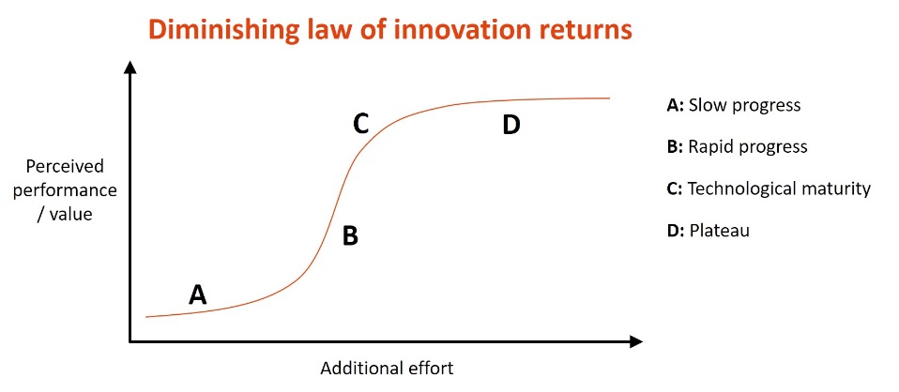
  - At some point, when the most valuable improvements have been made, value per iteration reverts back to a minimal level

- Incumbent sized deals. The incumbent has the luxury of a large customer set, which comes with high expectations of yearly sales. New entrants do not require the same levels of early sales thus have more time to focus on a segment and innovate in their venture.
  - Incumbent’s product is nearing the end of its S-curve and has limited scope for further innovation and added value
  - Next-gen product is in the middle of its S-curve thus is providing significant value
  - By the tie the new product begins to attract the incumbent’s customers, it is at the vertical stage of its S-curve and it is too late for the incumbent to react to match this level of improvement.

Principles to address
Christensen argues the following are common issues that incumbents should address:
- Resource dependence: current customers drive a company’s use of resources
- Disruptive technologies have fluid futures, it is hard to know what industries they will disrupt once matured
- Incumbent’s value includes their processes and core capabilities, which should drive their efforts
- Technology supply may not equal market demand. This is an attribute that makes technology unattractive in established markets, but give them great value in emerging markets.

Potential strategies
- Develop disruptive technology with the right customers, not necessarily their current customer set
- They then place the disruptive technology into an autonomous organisation that can be rewarded with small wins and customer sets
- They fail early and often to find the correct disruptive technology
- They allow the disruption organisation to utilise all of the company’s resources but are careful to make sure they do not give away their processes and values

YouTube summary

Sustaining vs disruptive innovation
- Sustaining innovation is improving a product’s performance based on feedback
  - Usually reducing defects, improving performance and quality
- Disruptive innovation often involves lower performance in key areas, with more defects
  - Large company cannot adopt this technology
  - However, this technology will benefit from its position on the S-curve
- Sustaining innovation satisfies current needs but disruptive innovation meets future needs. So, the incumbent needs to employ the disruptive innovation to avoid becoming obsolete in the future, but also cannot subject its consumers to the lower quality the disruptive innovation currently provides
  - This is the innovator’s dilemma

Takeaways for large incumbents
- Companies must be attentive to customers to successfully continue sustaining innovation, but must also look at niche markets to identify potentially disruptive innovations and embrace them.

